
UNIVERSITY OF PUNE
INTERDISCIPLINARY SCHOOL OF SCIENTIFIC COMPUTING
Mid Sem Exam - I
Course No. : SC 104
Title : Mathematics for Scientific Computing

Date : 02 / 09 / 2015 Marks : 40
Time : 11:00 am to 1:00pm

Q.1 Attempt any six . ( 2 marks each.)
(i) Plot the graph of 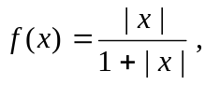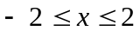
lim
x → - a aaaaaaaaaaana
(ii) Evaluate the limit 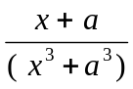

(iii) Evaluate the limit 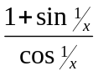
lim
x → ∞ aaaaaaaaaaana

(iv)What value of “  ” will make the given function continuous ?
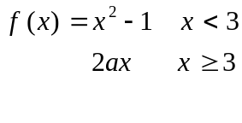
(v) Find  from the equation : 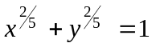
(vi) Find if 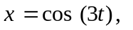 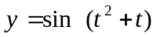

(vii) Locate and classify the critical points of 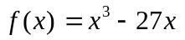

(viii) Find the equation of the tangent line to the curve 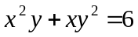 at the point
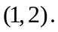
(IX) Evaluate the integral 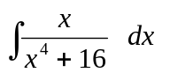

Q.2 Consider the function 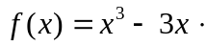
(i) Find the regions in which 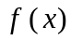 is increasing, decreasing, concave up and (3)
concave down.
(ii) Find the point of inflection. Locate and classify the critical points. (2)
(iii) Plot the curve for 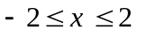 (2)
Q.3 (a) Two sides of a triangle are a cm and b cm resp. What should be the angle (4)
between them so that the area of the triangle is maximum?
OR
- Find the dimensions of the largest sphere that can be inscribed in the right (4)
circular cone of base radius and height = 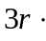

- A point moves on the curve 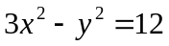 so that its 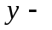coordinate increases (3)
at the rate of 6 meters per second. At what rate is the 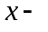coordinate changing
when 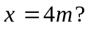

Q.4 (a) Show that the polynomial 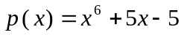has only one zero in 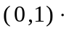 (2)
lim
x → ∞
(b) Evaluate the limit 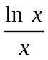 (2)
(c) Show that 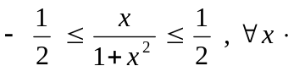 (3)
Let 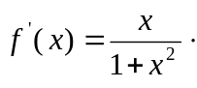
Show that for any 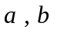 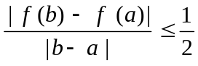
Q.5 (a) Evaluate any 2 integrals. (2 marks each.)
(i) 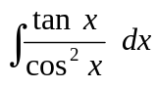 (ii) 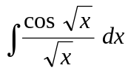 (ii) 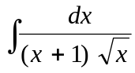
(b) Evaluate any one integral. ( 3 marks )

(i) 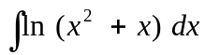 (ii) 